BSC – HGP - Assignment 01

Stock Trade Profit Calculator

UI Design Document

The Stock Trade Profit Calculator application calculates the purchase and sell total on the specific dates selected by the user and computes the profit between the two dates.

The labels are placed on the left side of the application as it makes it easier to read the label and then change the data on the right.

The writing is done in black color on a grey background color as it is seen more clearly and easy to read.

The image below shows how the application look when it is opened.

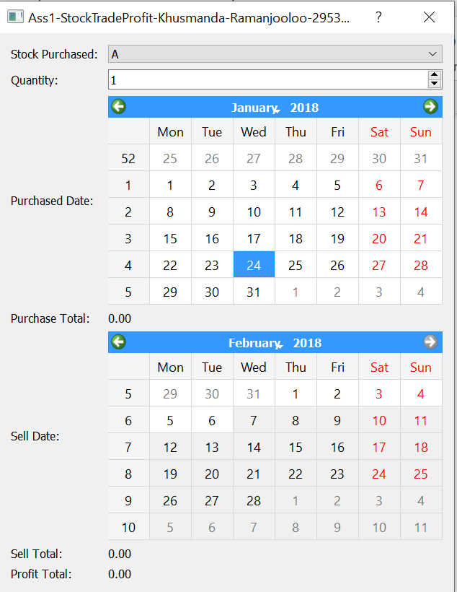

Labels

Calendar

Calculated value

*Stock Purchase*

Stock purchase is designed with a combo box which has a list of stock items from the CSV file. The combo Box is placed on the right, beside the label for stock purchased. Upon selecting a stock name, it is highlighted in blue background with white writing, so it is more visible.

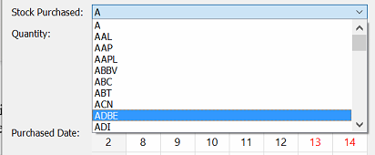

*Quantity*

Quantity uses a Spin Box to increase and decrease the quantity by clicking on the arrow. The quantity is set to 1 as it must be more than 0 to perform calculations.

*Purchase date and sell date*

Purchase date and sell date use calendar widget. By default, the calendar’s date weekdays are in black and the weekends are in red. The purchase date is set to 24/01/2018 and sell date is set as maximum date which is 7/02/2018 initially.

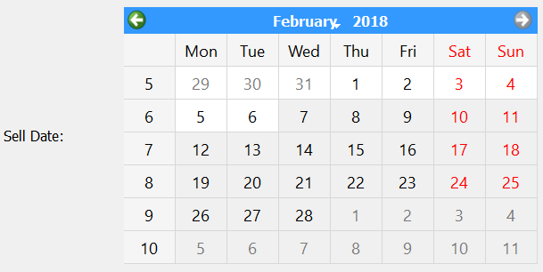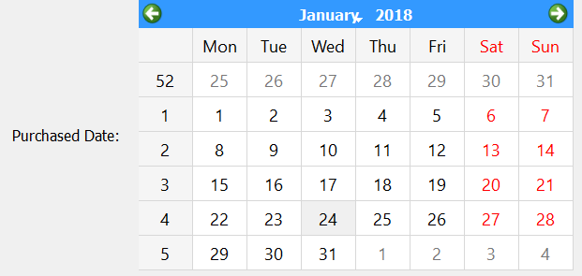

*Purchase Total and Sell Total*

Purchase total and sell total are computed values. The price for one single of the stock name is taken and is multiply by the quantity to obtain both purchase total and sell total. The calculated value uses label to be displayed in terms of float. By default, it is written in black color.



*Profit*

Profit is calculated after finding the sell total and the purchase total. Profit subtracts the purchase total from the sell total It uses a label to be displayed and it is written in black.

*How it works*

When the stock name is changed, purchase total, sell total and profit are changed. The chosen stock name in this example is ANDV. The purchase date by default is set to 24/01/2018, therefore the price for one ANDV is the purchase total. The sell date by default is set to 7/02/2018, therefore the selling price of that item is the total sell. The profit is calculated and shown at the bottom which is -15.95.

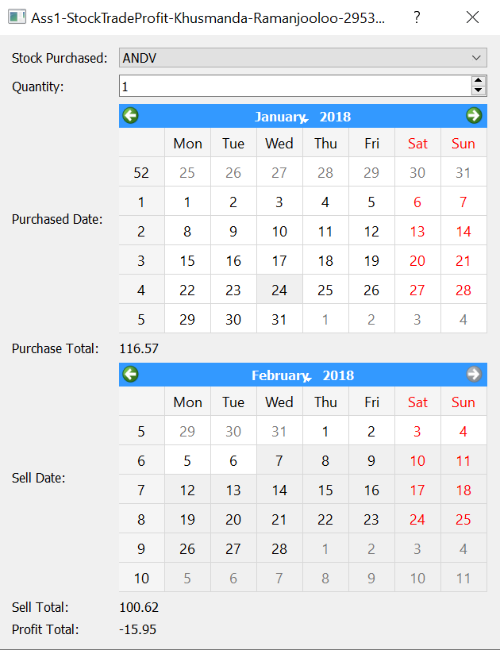

When the quantity is changed to 3, the total purchase, sell total and profit is updated accordingly.

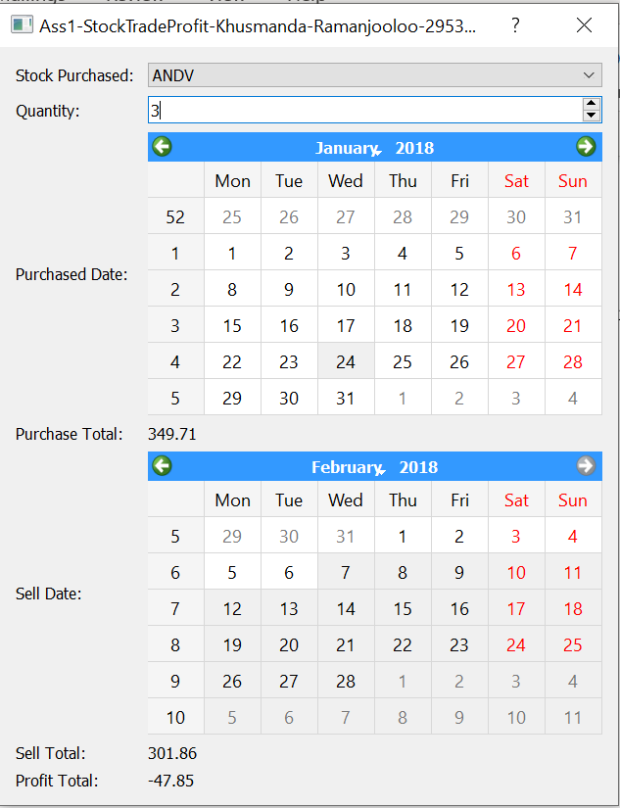

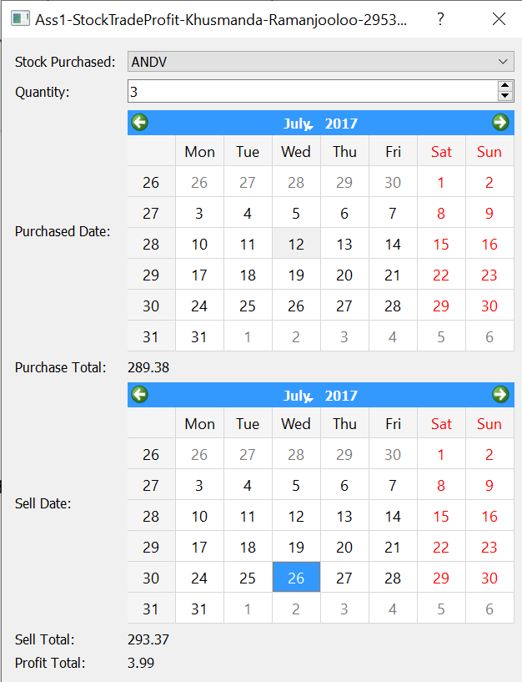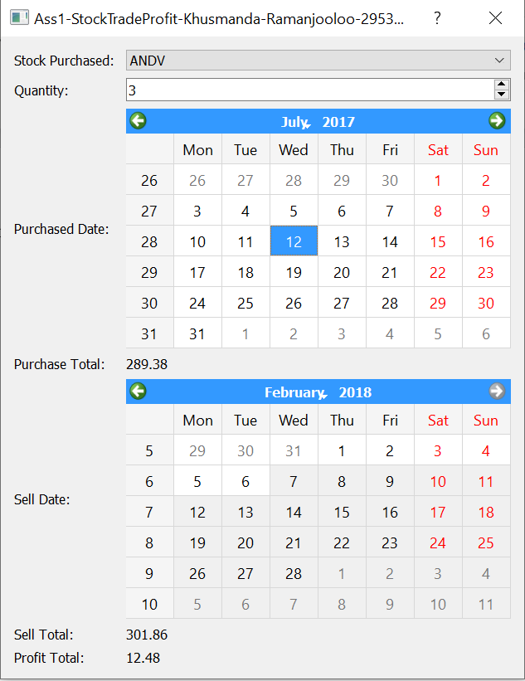When the purchase date and sell date are changed, the price of the item ANDV for those date also changes. And purchase total, sell total and profit is also changed accordingly.

*Features not working*

When the date is selected, it does not make it 14 days difference with sell date most recent.